Tables: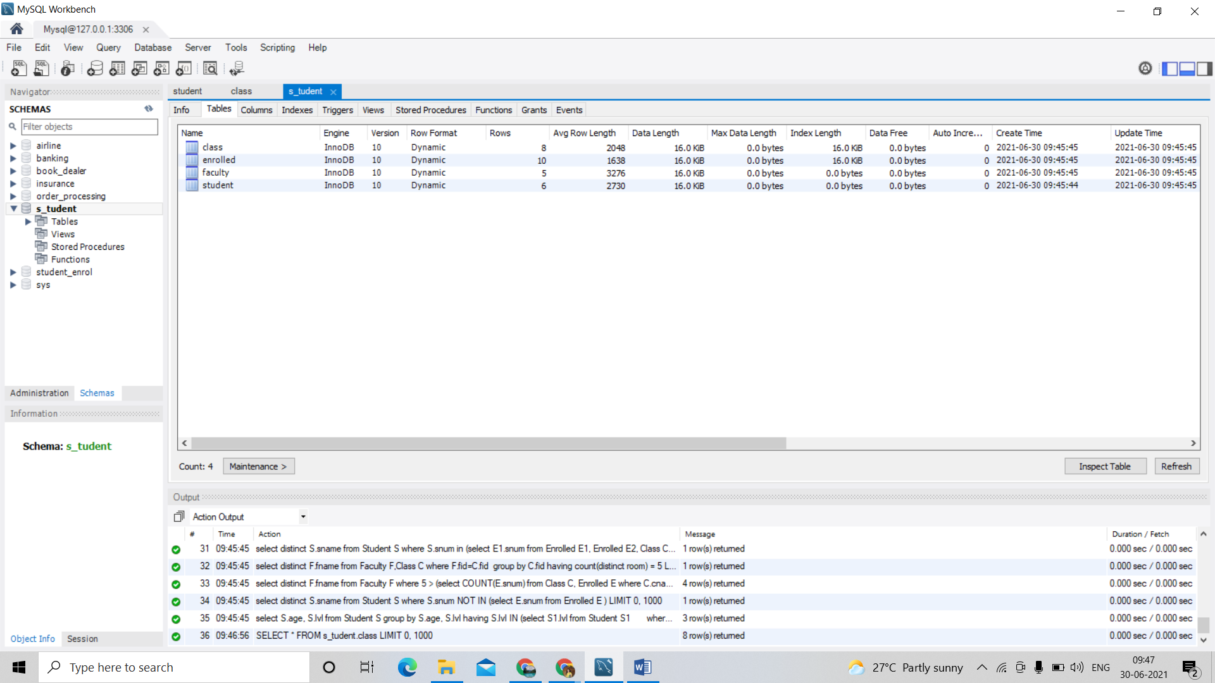

Columns:

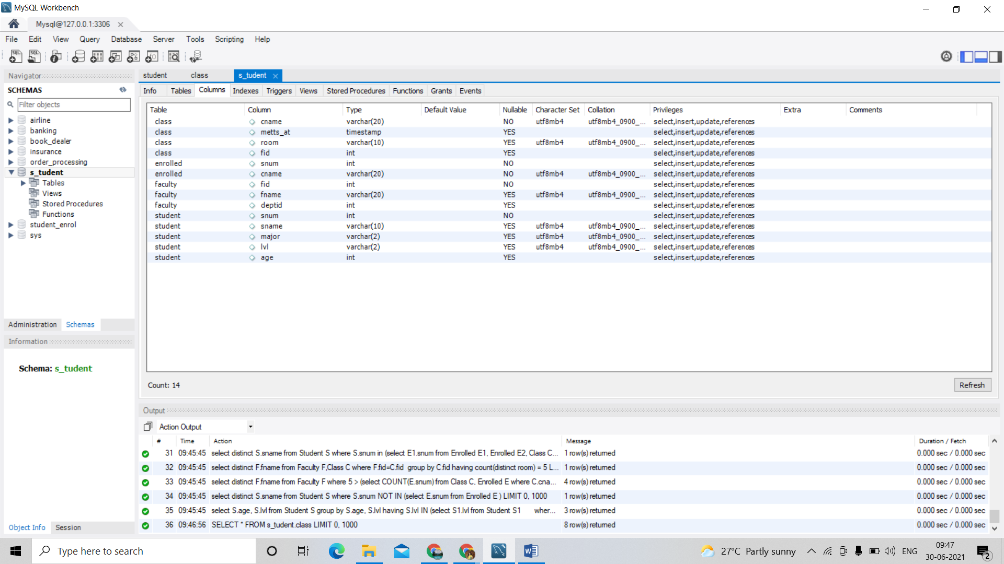

Indexes :

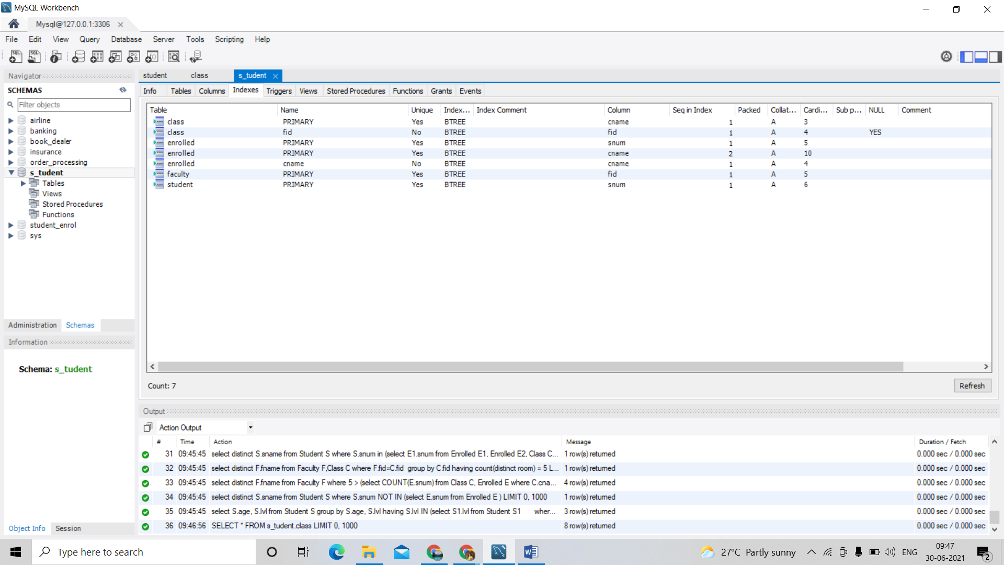

SELECT * FROM s_tudent.class; 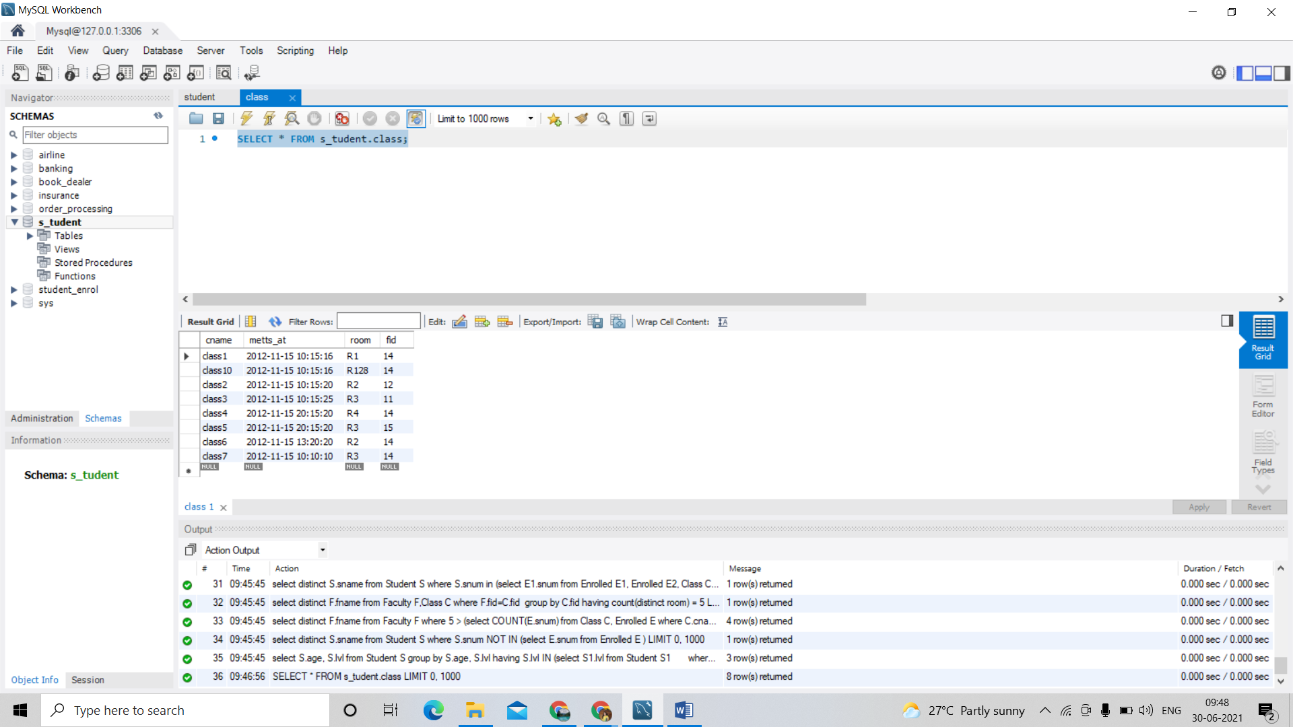

SELECT * FROM s_tudent.enrolled;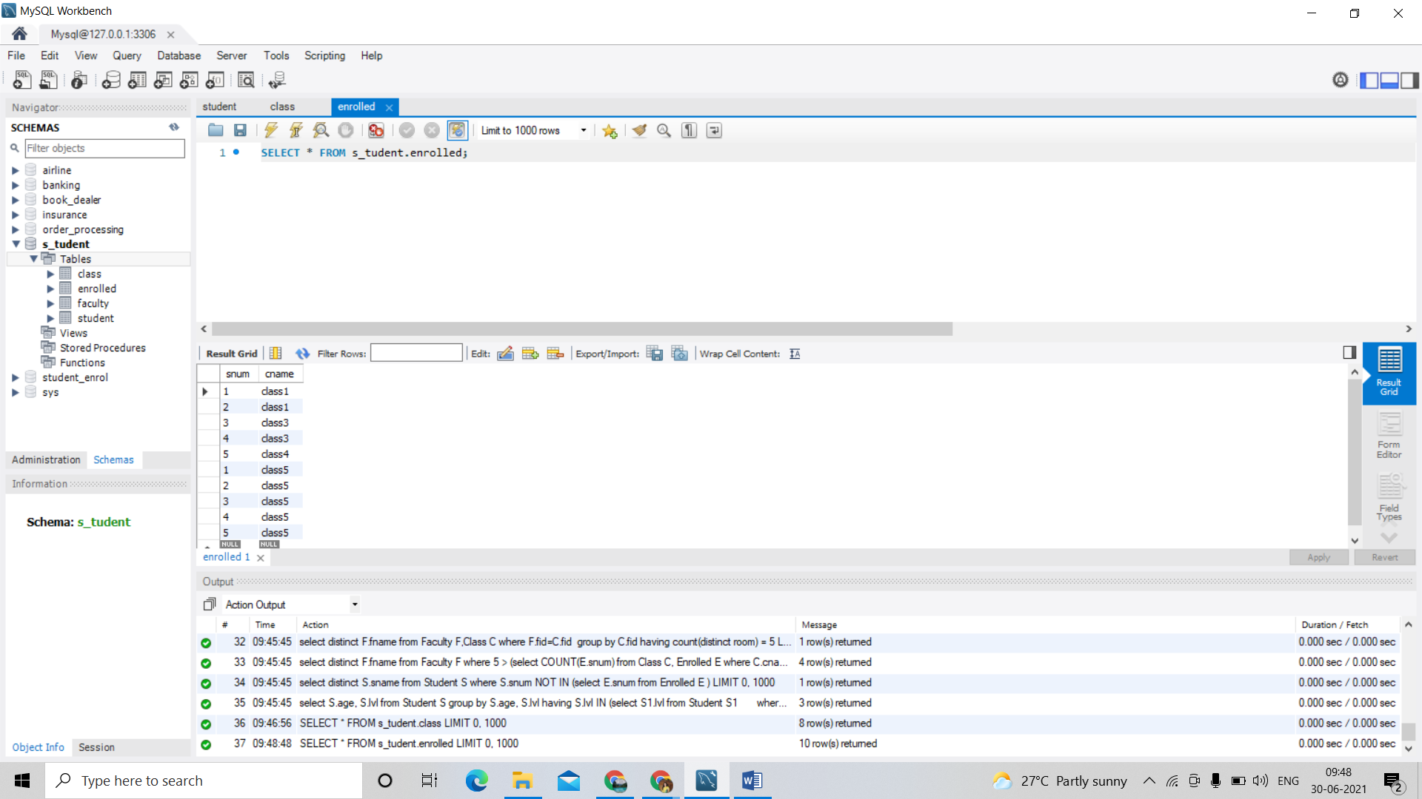

SELECT * FROM s_tudent.faculty; 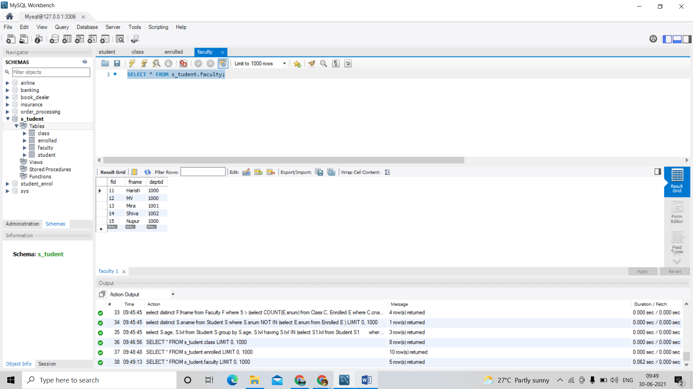

SELECT * FROM s_tudent.student;

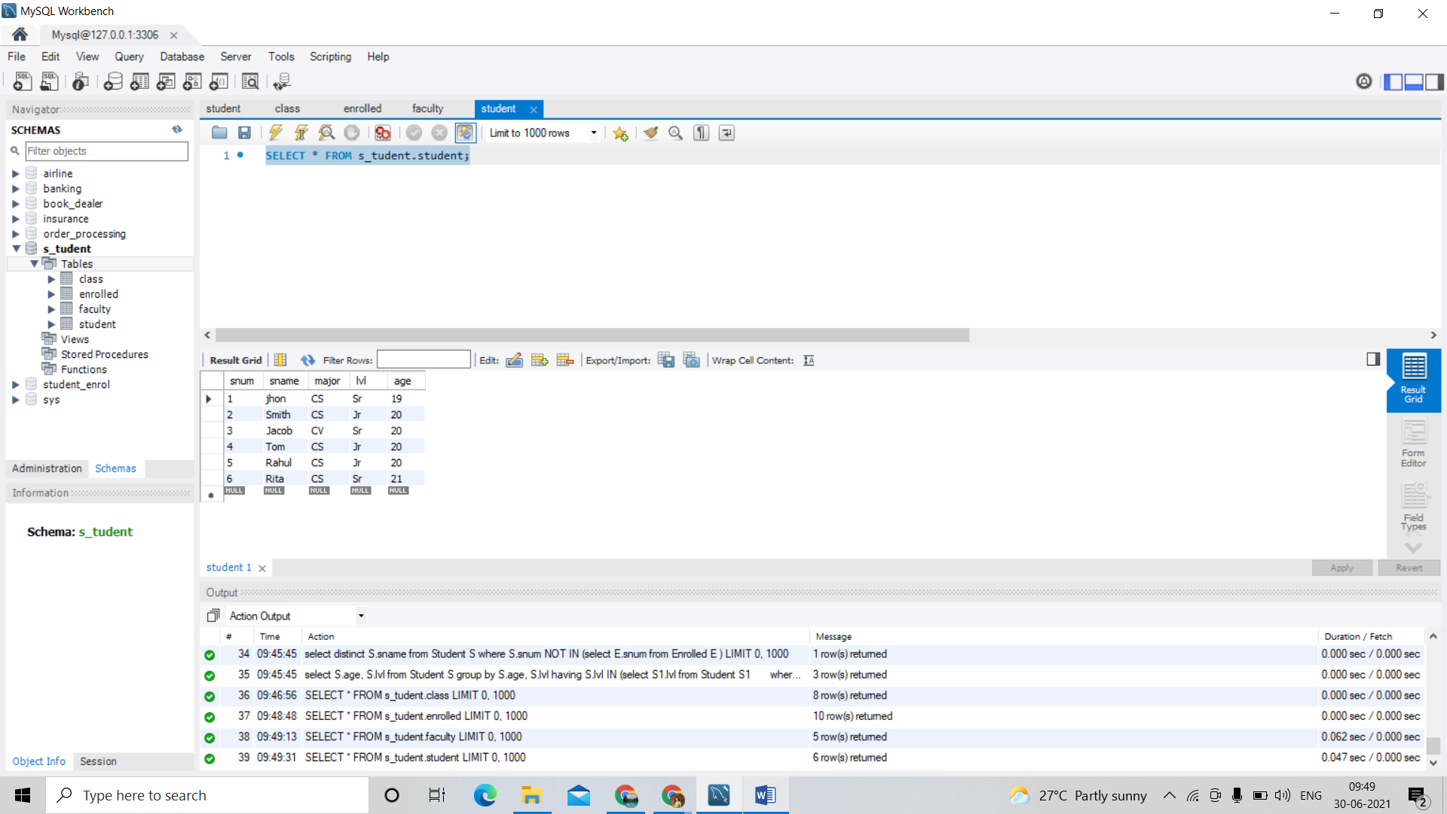

1. Find the names of all Juniors (level = JR) who are enrolled in a class taught by Harish.

select distinct s.sname

from student s, class c, enrolled e, faculty f

where s.snum = e.snum and e.cname = c.cname and c.fid = f.fid and

f.fname ='Harish' and s.lvl ='Jr';

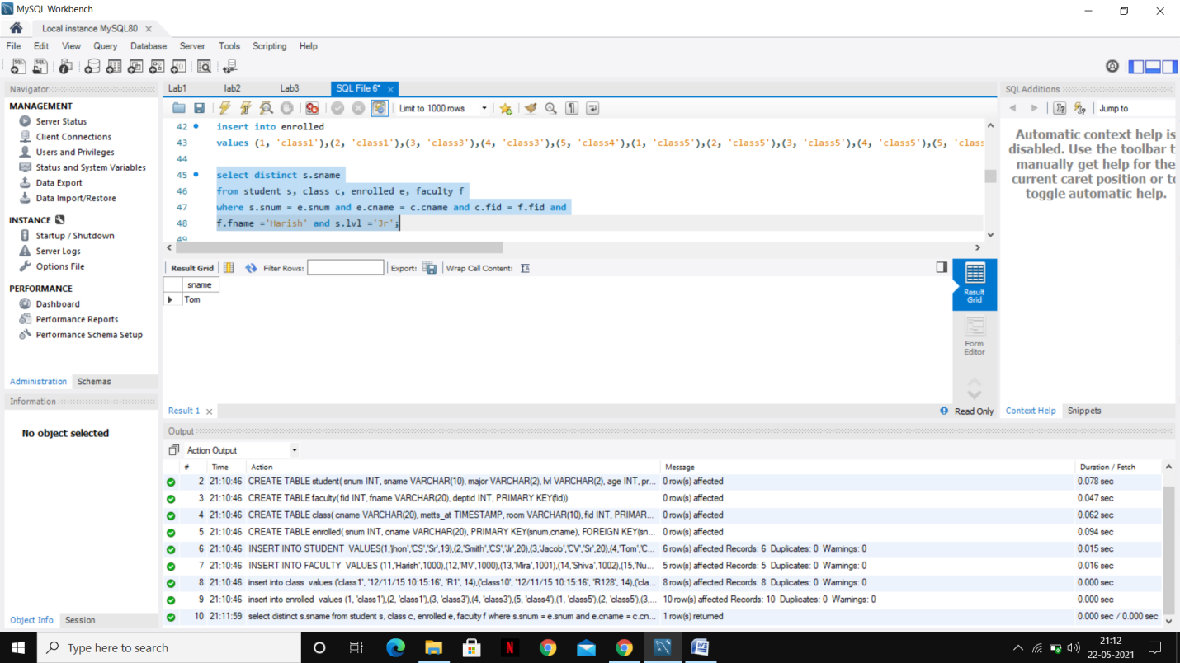

1. Find the names of all classes that either meet in room R128 or have five or more Students enrolled.

select C.cname

from Class C

where C.room = 'R128'

or C.cname in (select E.cname

FROM Enrolled E

GROUP BY E.cname

HAVING COUNT(E.snum) >= 5);

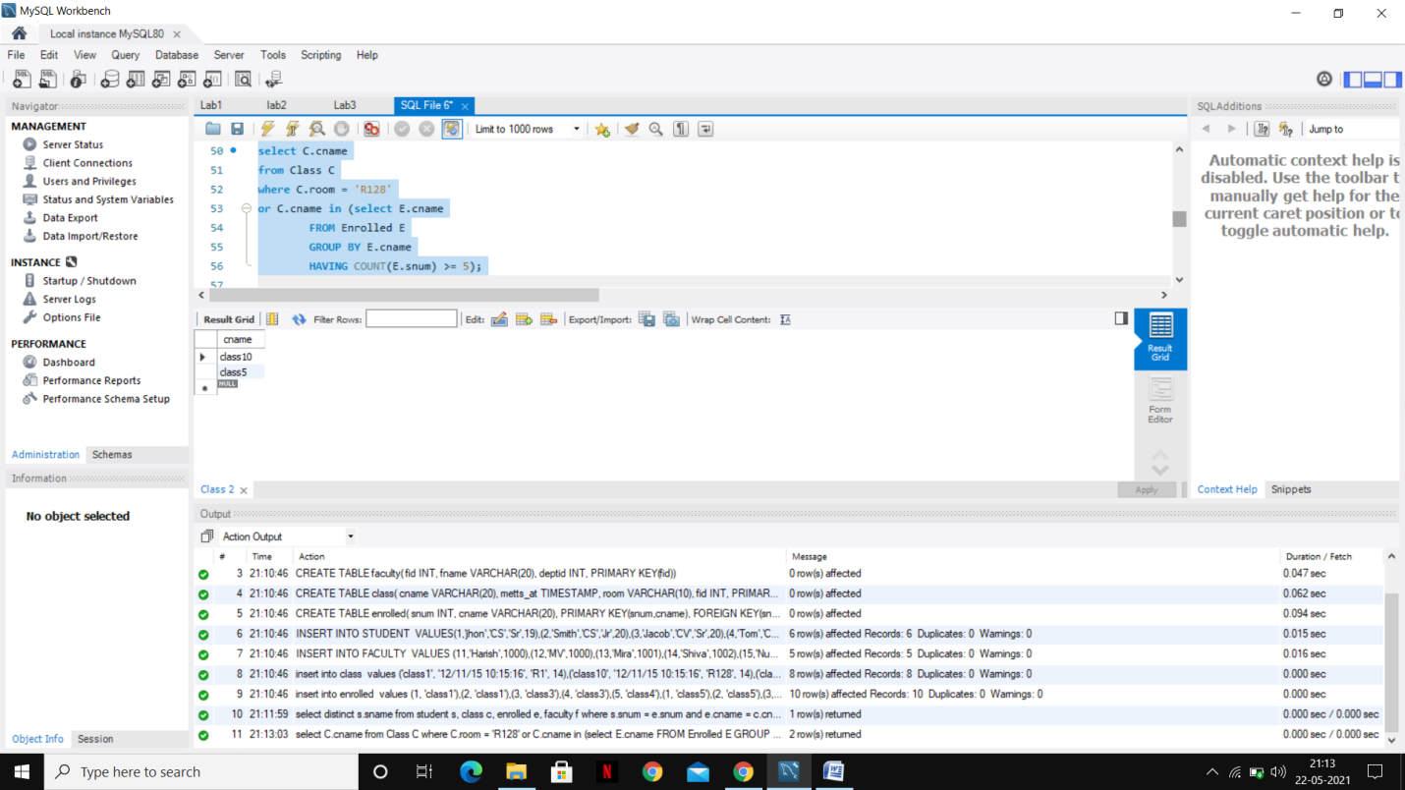

1. Find the names of all students who are enrolled in two classes that meet at the same time.

select distinct S.sname

from Student S

where S.snum in (select E1.snum

from Enrolled E1, Enrolled E2, Class C1, Class C2

where E1.snum = E2.snum AND E1.cname <> E2.cname

AND E1.cname = C1.cname

AND E2.cname = C2.cname AND C1.metts_at = C2.metts_at);

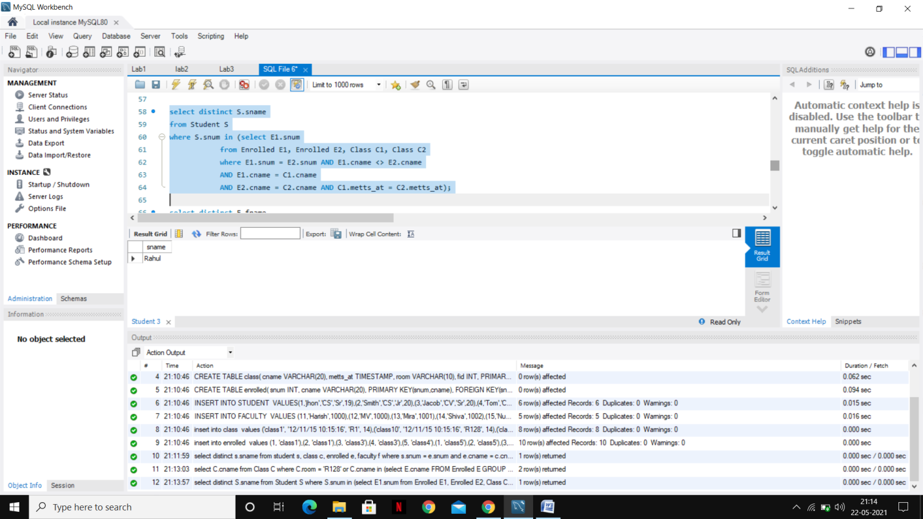

1. Find the names of faculty members who teach in every room in which some class is taught.

select distinct F.fname

from Faculty F,Class C

where F.fid=C.fid

group by C.fid

having count(distinct room) = 5;

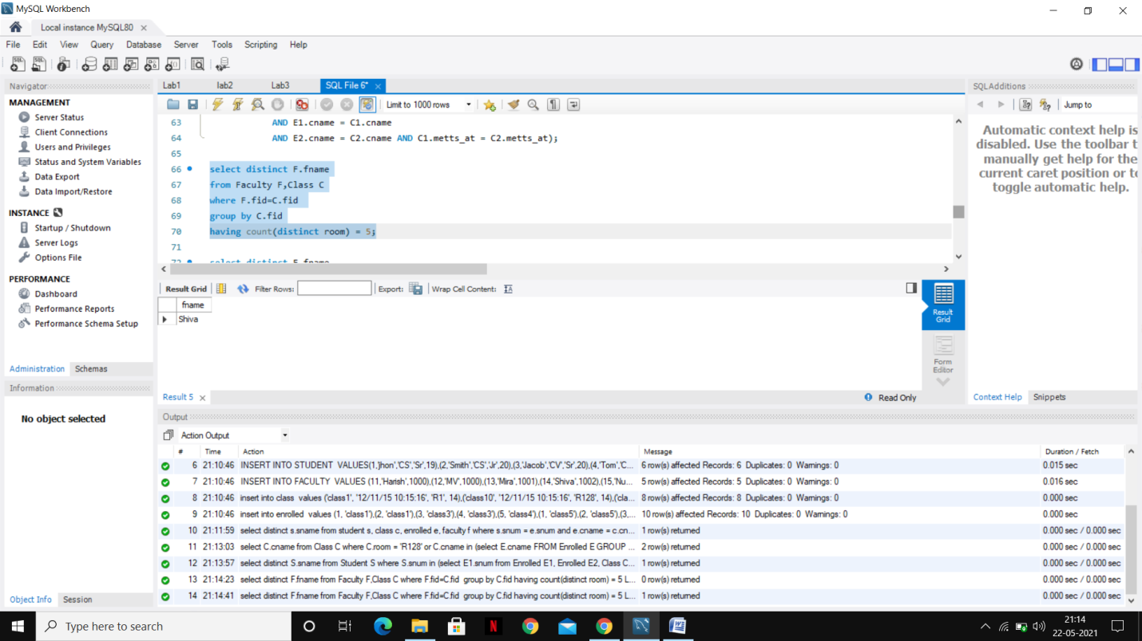

1. Find the names of faculty members for whom the combined enrollment of the courses that they teach is less than five.

select distinct F.fname

from Faculty F

where 5 > (select COUNT(E.snum)

from Class C, Enrolled E

where C.cname = E.cname

and C.fid = F.fid);

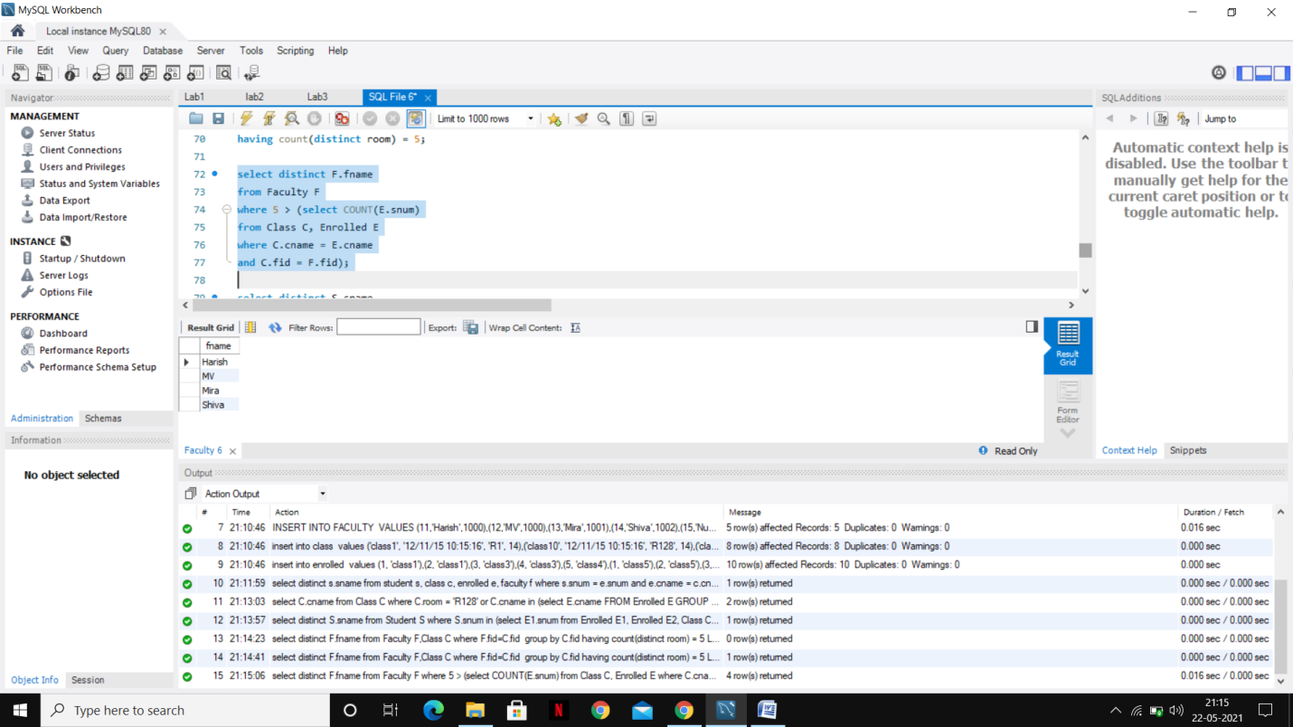

1. Find the names of students who are not enrolled in any class.

select distinct S.sname

from Student S

where S.snum NOT IN (select E.snum

from Enrolled E );

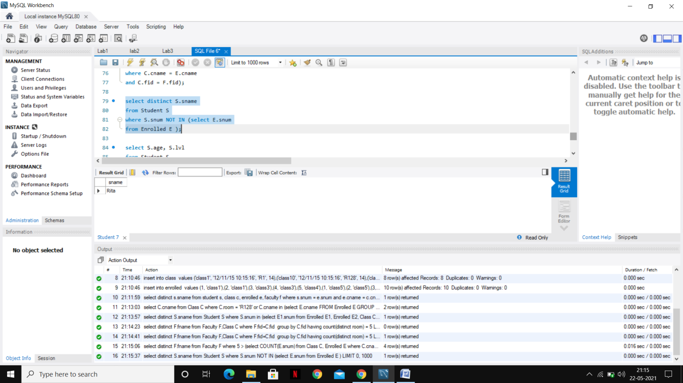

1. For each age value that appears in Students, find the level value that appears most often. For example, if there are more FR level students aged 18 than SR, JR, or SO students aged 18, you should print the pair (18, FR).

select S.age, S.lvl

from Student S

group by S.age, S.lvl

having S.lvl IN (select S1.lvl from Student S1

where S1.age = S.age

group by S1.lvl, S1.age

having COUNT(S1.snum) >= ALL (select COUNT(S2.snum)

from Student S2

where s1.age = S2.age

group by S2.lvl, S2.age));

